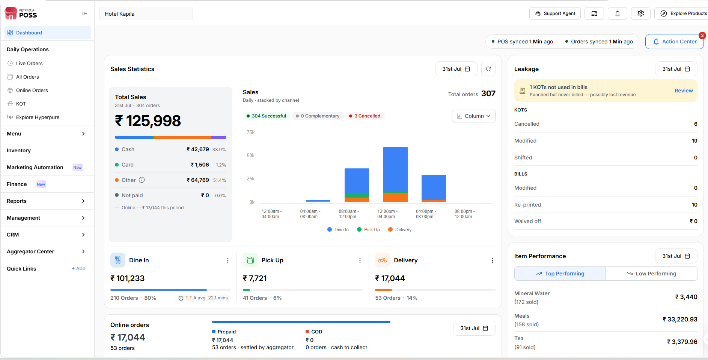

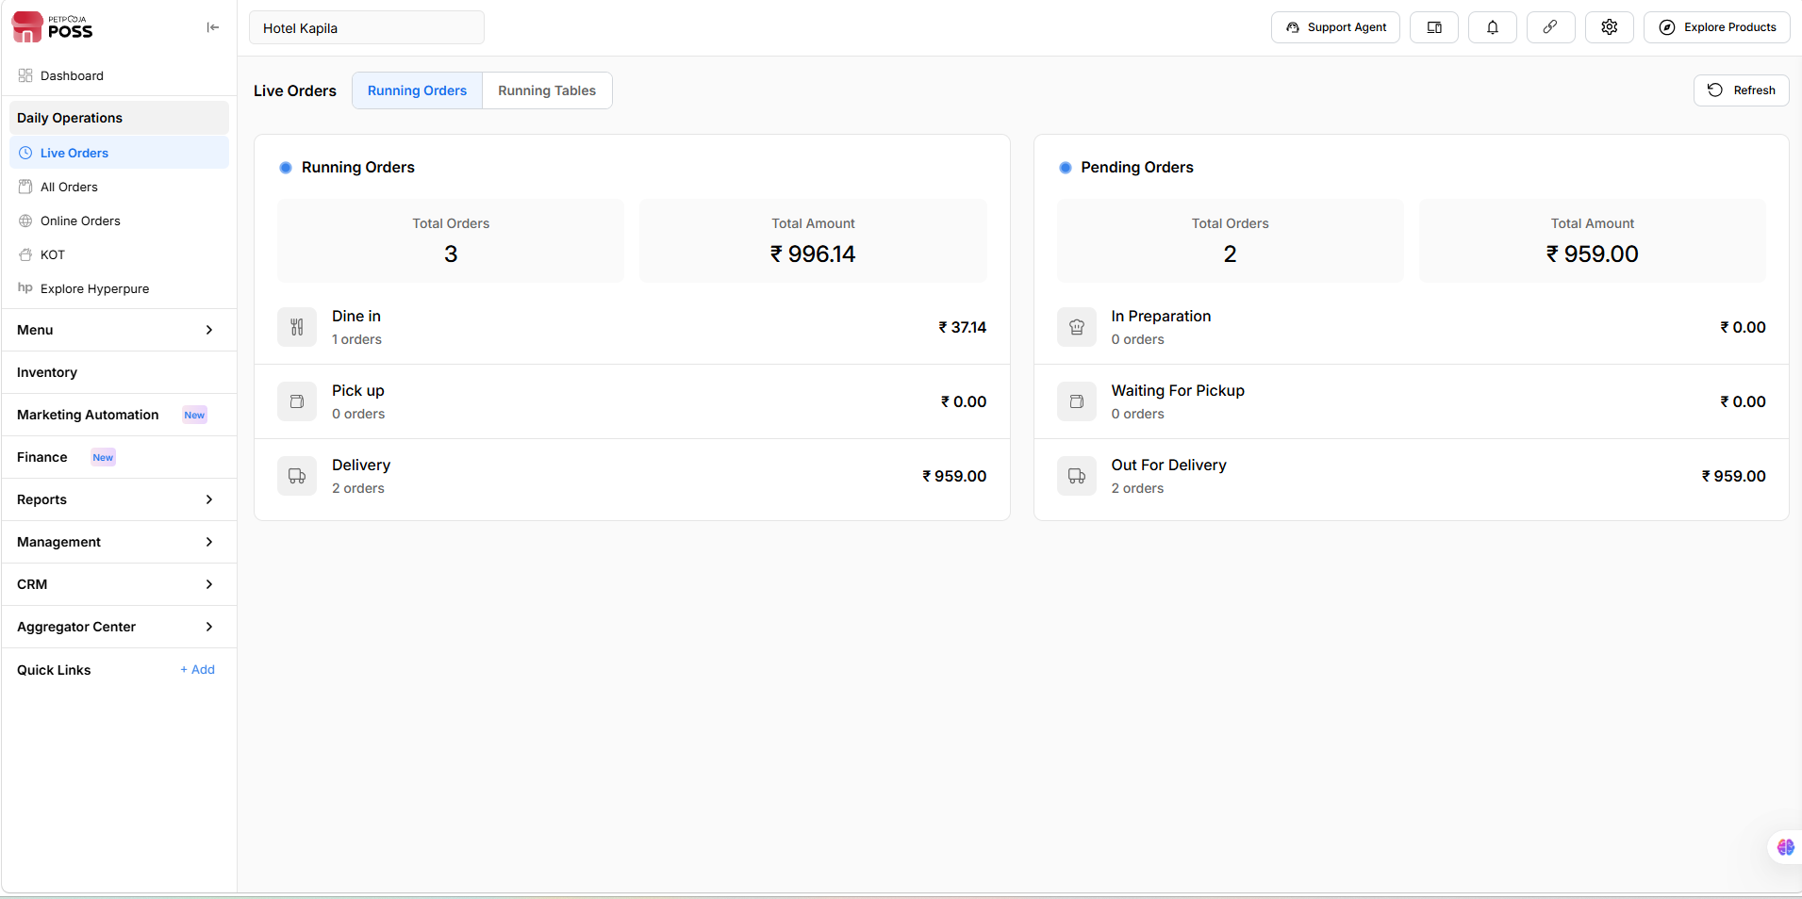
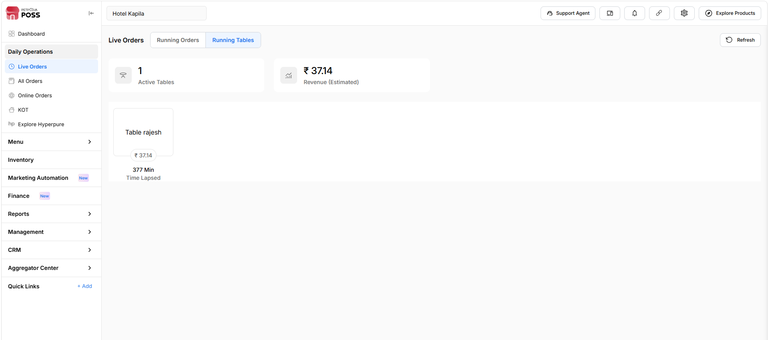

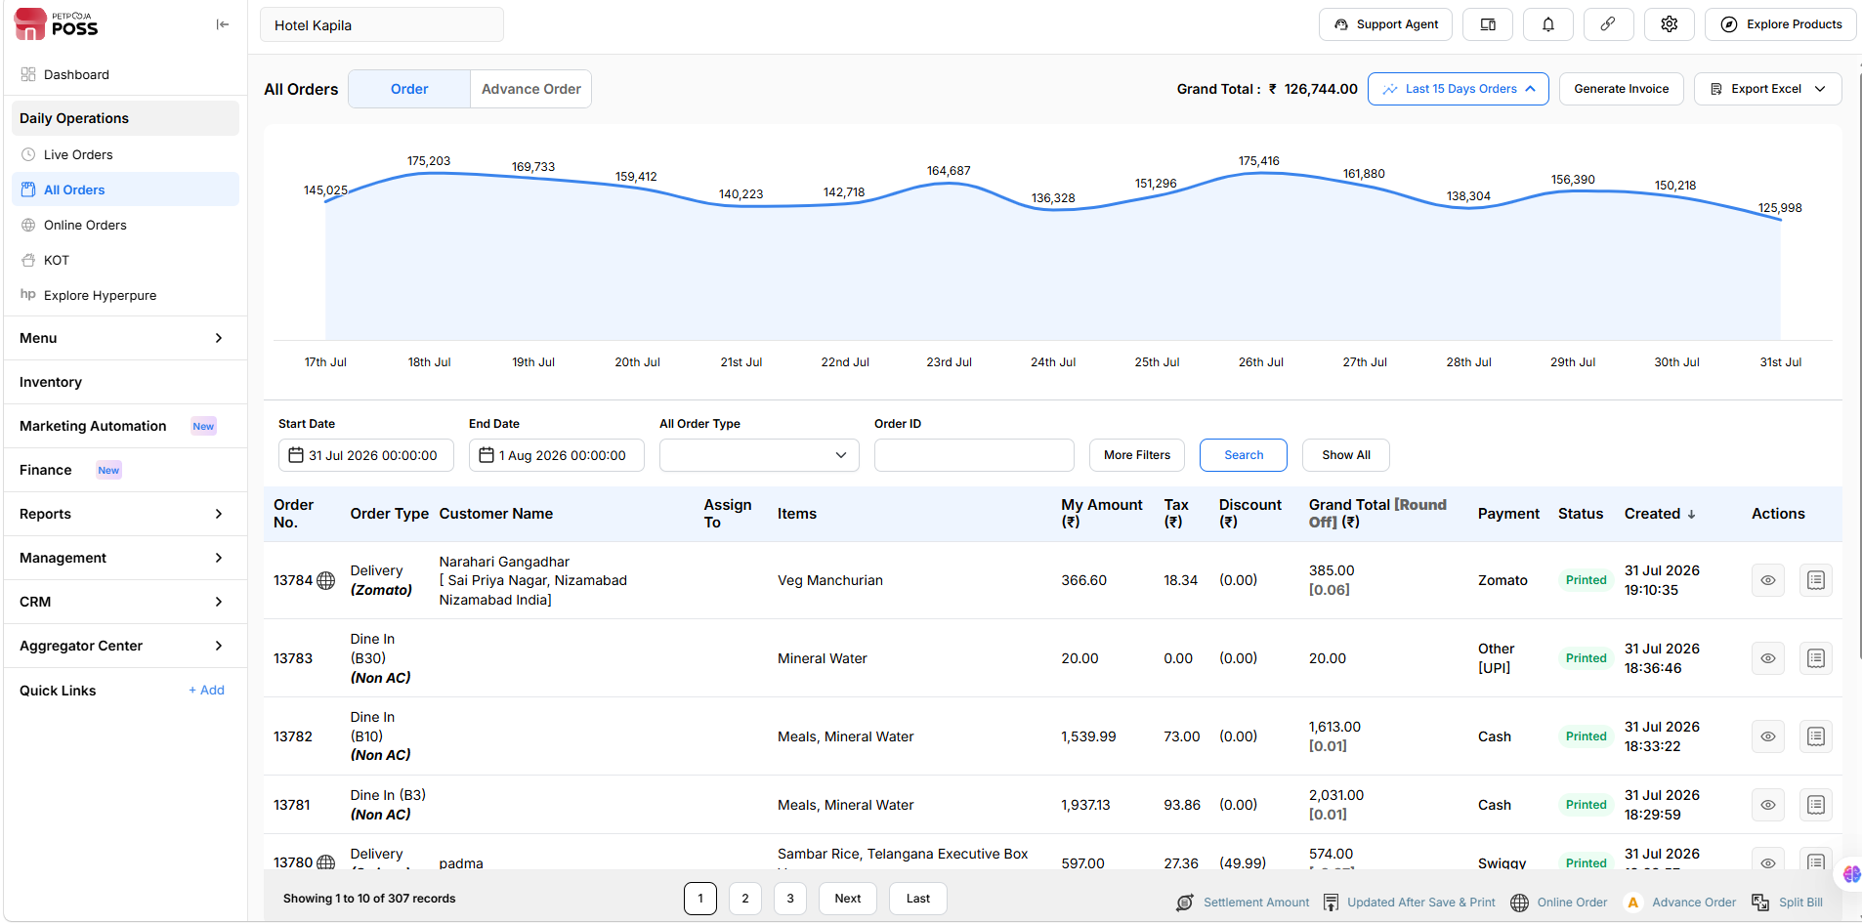

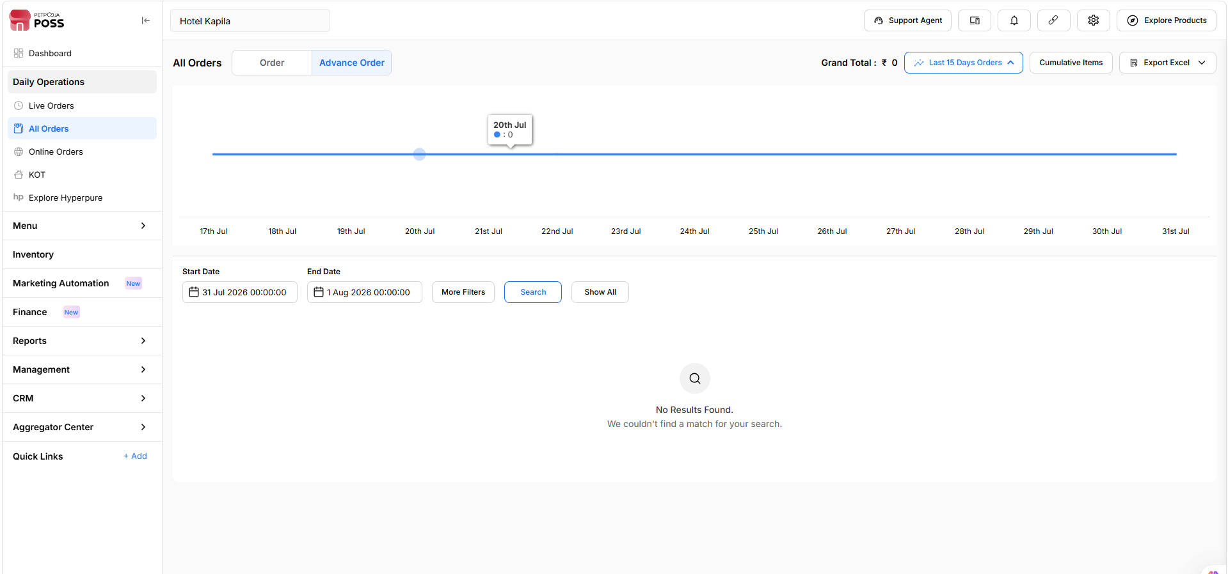

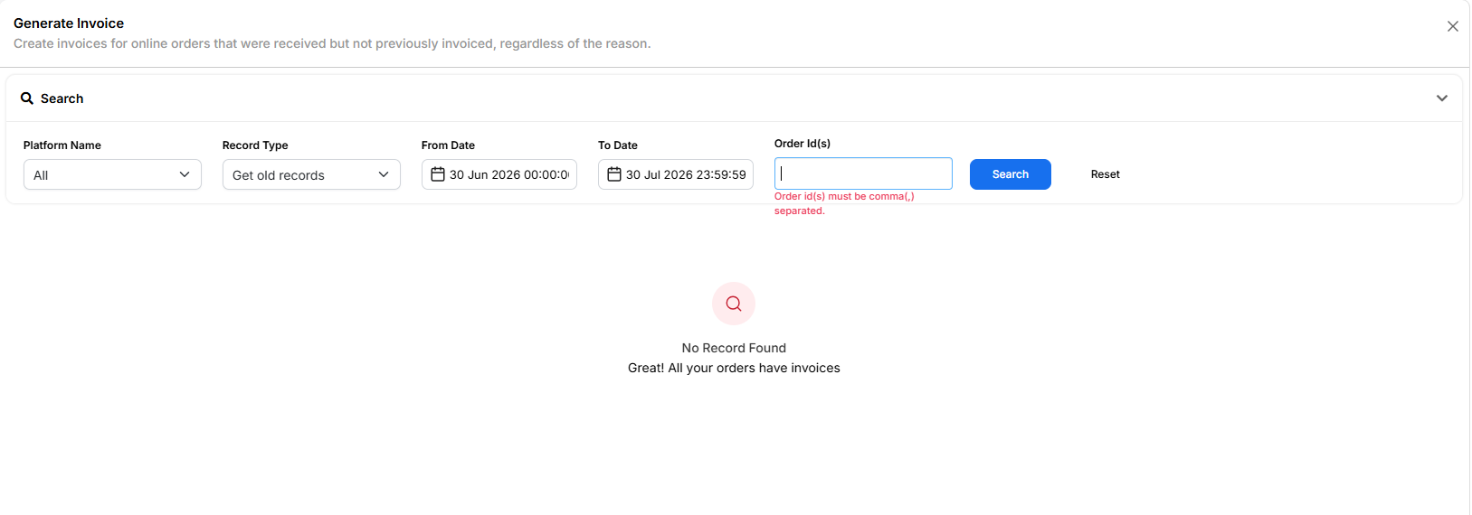

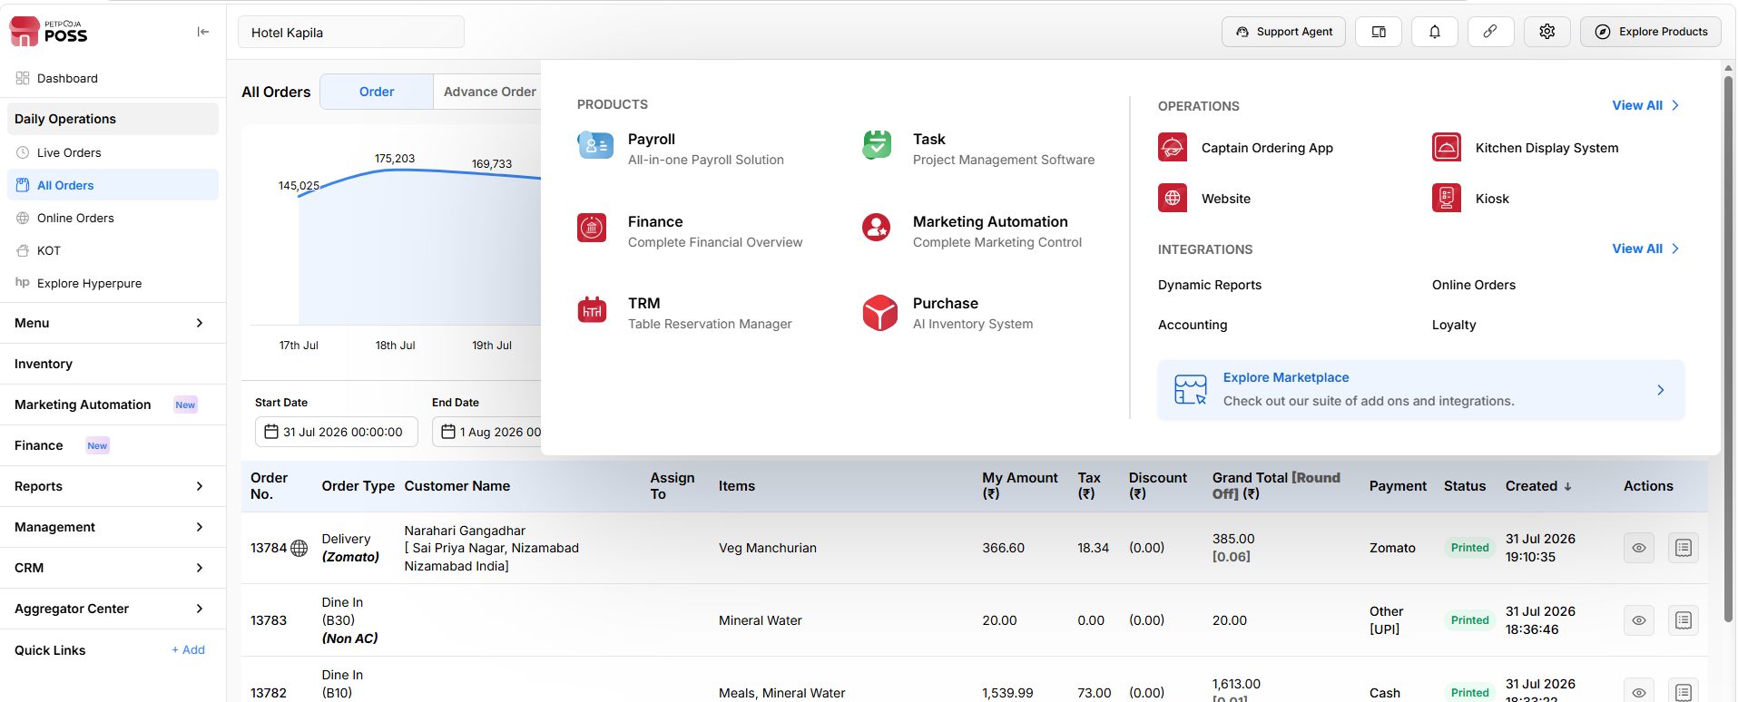

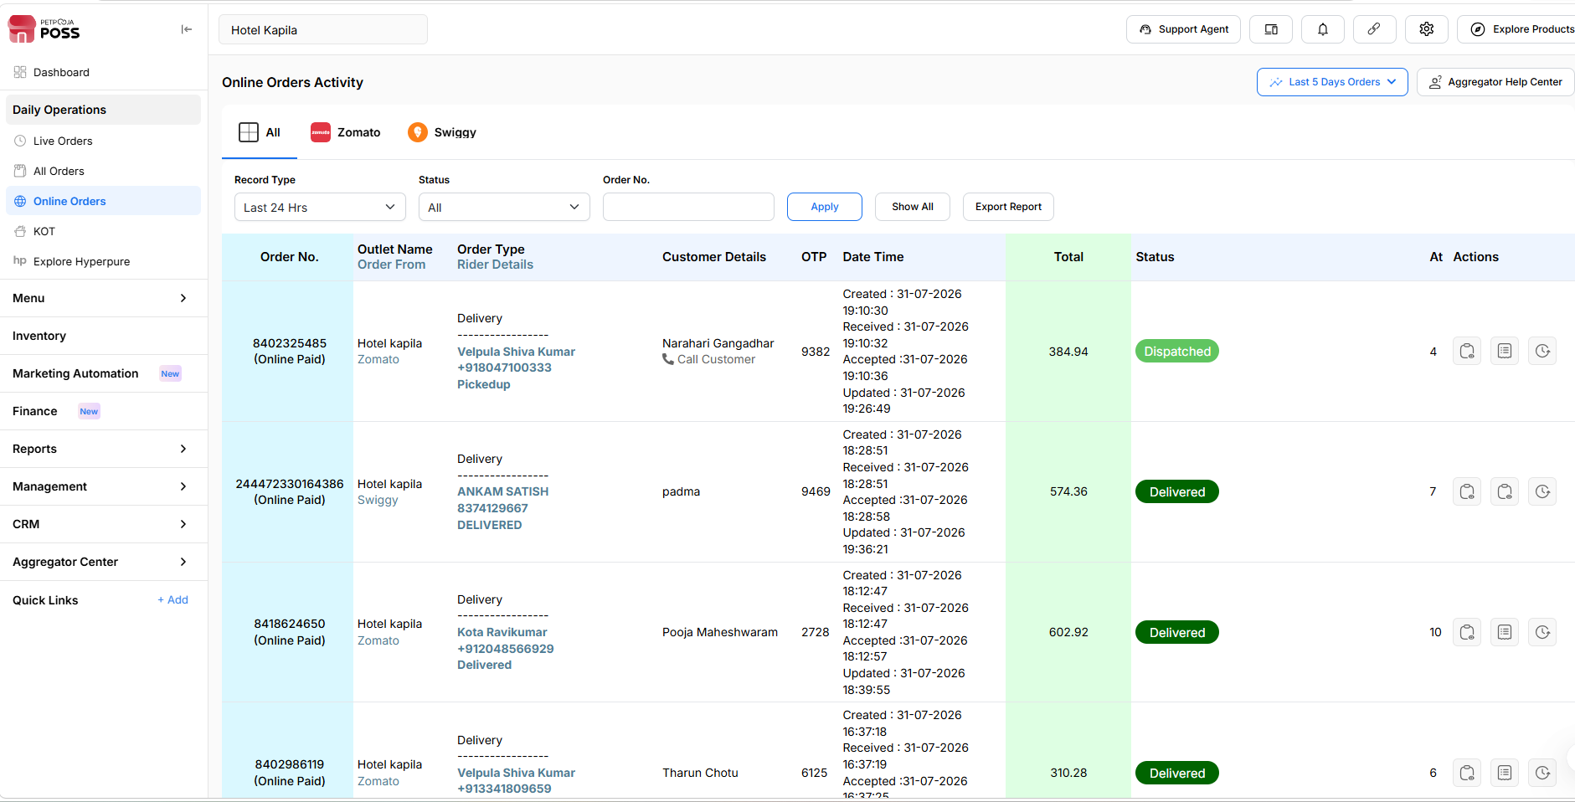

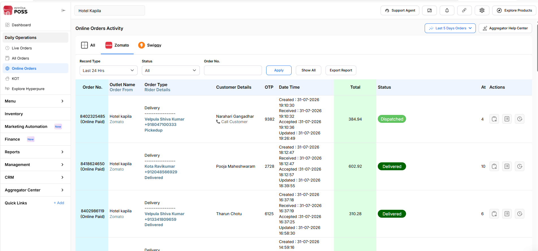

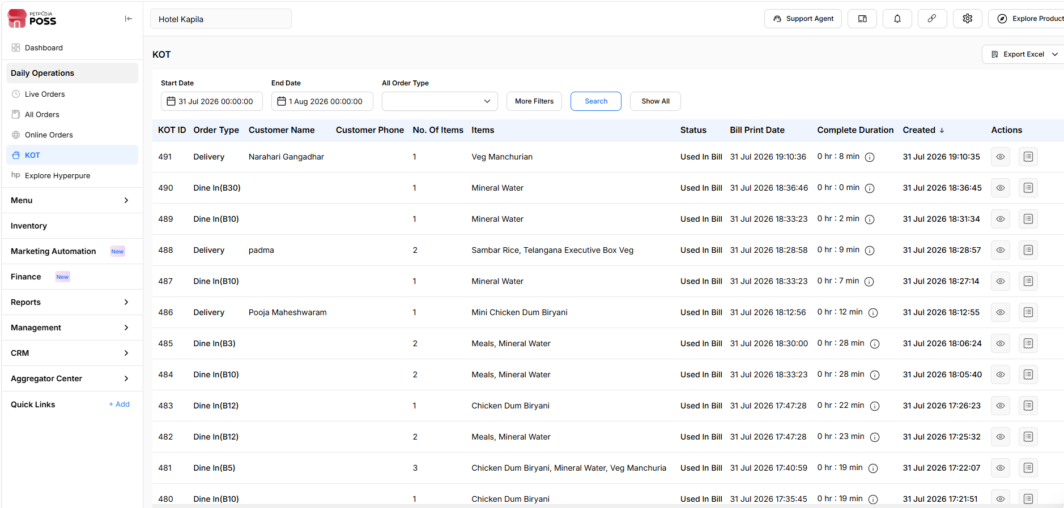

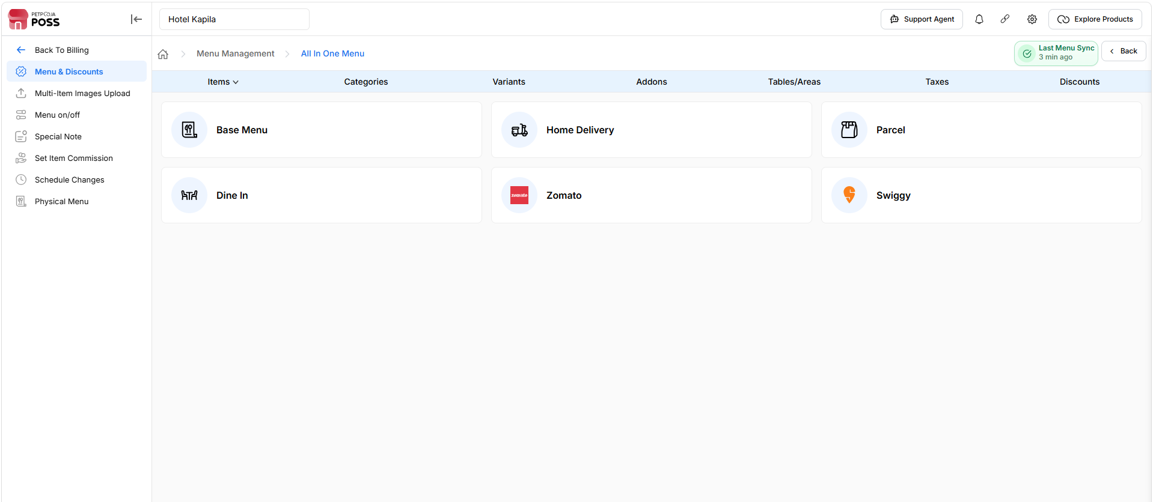

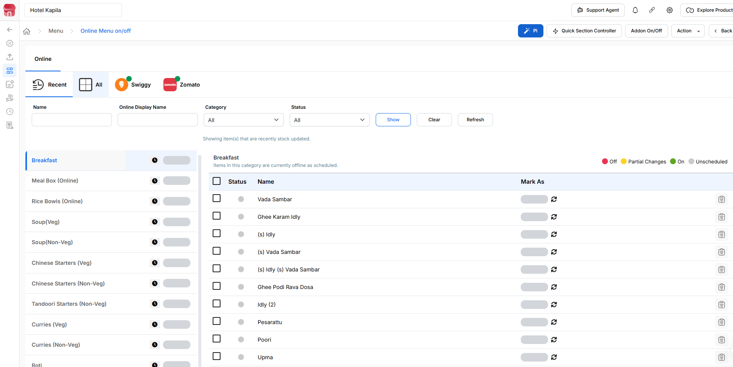

- Online

Recent

All

Swiggy

Zomato
Click here for stock update

Name
Online Display Name
CategoryAllSoup(Veg)Chinese Starters (Veg)Tandoori Starters (Veg)Noodles (Veg)Curries (Veg)Biryani (Veg)Flavour Rice (Veg)Soup(Non-Veg)Chinese Starters (Non-Veg)Tandoori Starters (Non-Veg)Curries (Non-Veg)Biryani (Non-Veg)Flavour Rice (Non-Veg)Noodles (Non-Veg)RotiFresh JuiceDessertCold BeverageBreakfastMealsHot BeveragesRice Bowls (Online)Meal Box (Online)Meals N.IButter Milk & LassiMOCKTAILSMilk ShakesExtra items
StatusAllOnOffPartial
ShowClearRefresh

Breakfast

Meal Box (Online)

Rice Bowls (Online)

Cold Beverage

Hot Beverages

Soup(Veg)

Meals

Soup(Non-Veg)

Chinese Starters (Veg)

Chinese Starters (Non-Veg)

Tandoori Starters (Veg)

Tandoori Starters (Non-Veg)

Curries (Veg)

Curries (Non-Veg)

Roti

Noodles (Veg)

Noodles (Non-Veg)

Biryani (Veg)

Biryani (Non-Veg)

Flavour Rice (Veg)

Flavour Rice (Non-Veg)

Dessert

Fresh Juice

Meals N.I

Butter Milk & Lassi

MOCKTAILS

Milk Shakes

Extra items

Breakfast
Items in this category are currently offline as scheduled.
Off
Partial Changes
On
Unscheduled
 | Status | Name | Mark as
 |  | Idly Sambar
 |  | Vada Sambar
 |  | Ghee Karam Idly
 |  | (s) Idly
 |  | (s) Vada Sambar
 |  | (s) Vada
 |  | (s) Idly (s) Vada Sambar
 |  | 70 Mm Dosa
 |  | Paper Dosa
 |  | Set Dosa
 |  | Onion Uttapam
 |  | Ghee Podi Rava Dosa
 |  | Extra Poori
 |  | Idly (2)
 |  | Vada
 |  | (2) Idly (1) Vada
 |  | (s) Idly (s) Vada
 |  | Masala Dosa
 |  | Onion Dosa
 |  | Plain Dosa
 |  | Butter Masala Dosa
 |  | Panner Dosa
 |  | Pesarattu
 |  | Poori
 |  | Upma
 |  | Rava Dosa
 |  | Ghee Podi Dosa
 |  | (s) Idly Sambar
 |  | Onion Rava Dosa
 |  | Breakfast Buffet
 |  | Kids Buffet
 |  | Chitti Pesarattu
 |  | Extra Aloo
 |  | Breakfast Combo
 |  | Thatte Idly
Meal Box (Online)
Off
Partial Changes
On
Unscheduled
 | Status | Name | Mark as
 |  | Telangana Executive Box Veg | ON
 |  | North Indian Meal Box | ON
 |  | South Indian Meal Box | OFF
 |  | Dal Khichdi Box | ON
 |  | Executive Meal Box (egg) | ON
 |  | Telangana Executive Box Non Veg | ON
 |  | Dal Khichdi Box ( Non - Veg ) | ON
 |  | Curd Rice Box | ON
Rice Bowls (Online)
Off
Partial Changes
On
Unscheduled
 | Status | Name | Mark as
 |  | Aloo 65 Sambar Rice Bowl | ON
 |  | Jeera Rice Bowl With Paneer Butter Masalaa | ON
 |  | Butter Chicken Jeera Rice Bowl | ON
 |  | Chicken 65 Sambar Rice Bowl | ON
 |  | Chicken Biryani + Sambar Rice + Curd Rice | ON
 |  | Steam Rice W/ Telangana Chicken Curry | ON
Cold Beverage
Off
Partial Changes
On
Unscheduled
 | Status | Name | Mark as
 |  | Alakaline | ON
 |  | Maaza 250ml | ON
Hot Beverages
Off
Partial Changes
On
Unscheduled
 | Status | Name | Mark as
 |  | Boost | ON
 |  | Horlicks | ON
 |  | Strong Filter Coffee | ON
Soup(Veg)
Off
Partial Changes
On
Unscheduled
 | Status | Name | Mark as
 |  | Corn Soup | ON
 |  | Veg Hot & Sour Soup | ON
 |  | Veg Manchow Soup | ON
Meals
Off
Partial Changes
On
Unscheduled
 | Status | Name | Mark as
 |  | Mini Meals | ON
 |  | Meals | ON
Soup(Non-Veg)
Off
Partial Changes
On
Unscheduled
 | Status | Name | Mark as
 |  | Chicken Manchow Soup | ON
 |  | Chicken Hot & Sour Soup | ON
Chinese Starters (Veg)
Off
Partial Changes
On
Unscheduled
 | Status | Name | Mark as
 |  | Veg Manchurian | ON
 |  | Crispy Corn | ON
 |  | Paneer Majestic | ON
 |  | Paneer Manchurian | ON
 |  | Rampuri Paneer | ON
 |  | Baby Corn Manchuria | ON
 |  | Paneer Tikka | ON
 |  | Chilly Paneer | ON
 |  | Andhra Paneer Vepudu | ON
Chinese Starters (Non-Veg)
Off
Partial Changes
On
Unscheduled
 | Status | Name | Mark as
 |  | Chicken Majestic | ON
 |  | Chicken Manchuria | ON
 |  | Chilly Chicken | ON
 |  | Pepper Chicken | ON
 |  | Rampuri Chicken | ON
 |  | Loose Prawns | ON
 |  | Apollo Fish | ON
 |  | Egg Chilli | ON
 |  | Masala Omelette | ON
 |  | Boild Egg | ON
 |  | Rampuri Prawns | ON
Tandoori Starters (Veg)
Off
Partial Changes
On
Unscheduled
 | Status | Name | Mark as
 |  | Kapila Veg Starters | ON
 |  | Kapila Special Veg Kabab | ON
Tandoori Starters (Non-Veg)
Off
Partial Changes
On
Unscheduled
 | Status | Name | Mark as
 |  | Chicken Tikka | ON
 |  | Tandoori Chicken (Half) | ON
 |  | Tandoori Chicken (Full) | ON
 |  | Tangdi Kabab (Half) | ON
 |  | Tangdi Kabab (Full) | ON
 |  | Kapila Special Chicken Kebab | ON
 |  | Kapila Non Veg Starter | ON
Curries (Veg)
Off
Partial Changes
On
Unscheduled
 | Status | Name | Mark as
 |  | Dal Fry | ON
 |  | Dal Tadka | ON
 |  | Kadai Veg | ON
 |  | Mixed Veg Curry | ON
 |  | Mushroom Butter Masala | ON
 |  | Kadai Paneer | ON
 |  | Paneer Butter Masala | ON
 |  | Kaju Butter Masala | ON
 |  | Palak Paneer | OFF
 |  | Kapila Spl Veg Curry | ON
 |  | Methi Chaman | ON
Curries (Non-Veg)
Off
Partial Changes
On
Unscheduled
 | Status | Name | Mark as
 |  | Butter Chicken | ON
 |  | Kadai Chicken | ON
 |  | Telangana Chicken Curry | ON
 |  | Egg Curry | ON
 |  | Egg Burji | ON
 |  | Kapila Spl Chicken Curry | ON
 |  | Extra Chicken Curry | ON
 |  | Egg Keema Masala | ON
 |  | Telangana Mutton Curry | ON
 |  | Desi Chicken | ON
Roti
Off
Partial Changes
On
Unscheduled
 | Status | Name | Mark as
 |  | Plain Naan | ON
 |  | Butter Naan | ON
 |  | Garlic Butter Naan | ON
 |  | Tandoori Roti | ON
 |  | Aloo Paratha | ON
 |  | Paneer Paratha | ON
 |  | Butter Roti | ON
 |  | Phulka 2pcs | ON
Noodles (Veg)
Off
Partial Changes
On
Unscheduled
 | Status | Name | Mark as
 |  | Veg Soft Noodles | ON
 |  | Schezwan Veg Noodles | ON
 |  | Manchurian Noodles | ON
Noodles (Non-Veg)
Off
Partial Changes
On
Unscheduled
 | Status | Name | Mark as
 |  | Egg Soft Noodles | ON
 |  | Chicken Soft Noodles | ON
 |  | Schezwan Chicken Noodles | ON
Biryani (Veg)
Off
Partial Changes
On
Unscheduled
 | Status | Name | Mark as
 |  | Veg Biryani | ON
Biryani (Non-Veg)
Off
Partial Changes
On
Unscheduled
 | Status | Name | Mark as
 |  | Chicken Dum Biryani | ON
 |  | Chicken Fry Piece Biryani | ON
 |  | Special Chicken Biryani (boneless) | ON
 |  | Fish Biryani | ON
 |  | Prawns Biryani | ON
 |  | Egg Biryani | ON
 |  | Mini Chicken Dum Biryani | ON
 |  | Mini Chicken Dum Biryani ( Double Masala ) | ON
 |  | Kapila Spl Non Veg Pulao | ON
 |  | Mutton Kheema Pulao | ON
Flavour Rice (Veg)
Off
Partial Changes
On
Unscheduled
 | Status | Name | Mark as
 |  | Veg Pulao | ON
 |  | Kaju Paneer Pulao | ON
 |  | Dal Khichdi | ON
 |  | Jeera Rice | ON
 |  | Tomato Rice | ON
 |  | Veg Fried Rice | ON
 |  | Sambar Rice | ON
 |  | Veg Kheema Pulao | ON
Flavour Rice (Non-Veg)
Off
Partial Changes
On
Unscheduled
 | Status | Name | Mark as
 |  | Egg Fried Rice | ON
 |  | Double Egg Fried Rice | ON
 |  | Chicken Fried Rice | ON
Dessert
Off
Partial Changes
On
Unscheduled
 | Status | Name | Mark as
 |  | Apricot Delight | OFF
 |  | Kulfi With Rabri | ON
 |  | Jamun Ka Ghosla | ON
 |  | Brownie With Icecream | ON
 |  | Brownie With Chocolate Sauce | ON
 |  | Cheese Kunafa | ON
 |  | Kunafa Choco Dream | ON
 |  | Kunafa Choco Vanilla | ON
 |  | Mini Apricot Delight | ON
Fresh Juice
Off
Partial Changes
On
Unscheduled
 | Status | Name | Mark as
 |  | Black Grape Juice | ON
Meals N.I
Off
Partial Changes
On
Unscheduled
 | Status | Name | Mark as
 |  | Executive Meals Non-veg | ON
Butter Milk & Lassi
Off
Partial Changes
On
Unscheduled
 | Status | Name | Mark as
 |  | Chocolate Lassi | ON
MOCKTAILS
Off
Partial Changes
On
Unscheduled
 | Status | Name | Mark as
 |  | Mint Mojito | ON
 |  | Blue Lagoon | ON
 |  | Watermelon Burst | ON
 |  | Fresh Lemon Soda | ON
 |  | Ginger Sparkler | ON
 |  | Kalakatta Syrup | ON
 |  | Virjin Mint Mojito | ON
Milk Shakes
Off
Partial Changes
On
Unscheduled
 | Status | Name | Mark as
 |  | Choco Brownie Milk Shake | ON
 |  | Biscoff Milkshake | ON
 |  | Kitkat Milkshake | ON
 |  | Oreo Milkshake | ON
 |  | Cold Coffee Milkshake | ON
 |  | Rose Gulkand Milkshake | ON
 |  | Cold Coffee | ON
Extra items
Off
Partial Changes
On
Unscheduled
 | Status | Name | Mark as
 |  | Chapathi | ON
 |  | Extra Poori (meals) | ON
 |  | Extra Chicken Curry (meals) | ON

